1. See all the data SELECT * FROM customers_shopping_data;

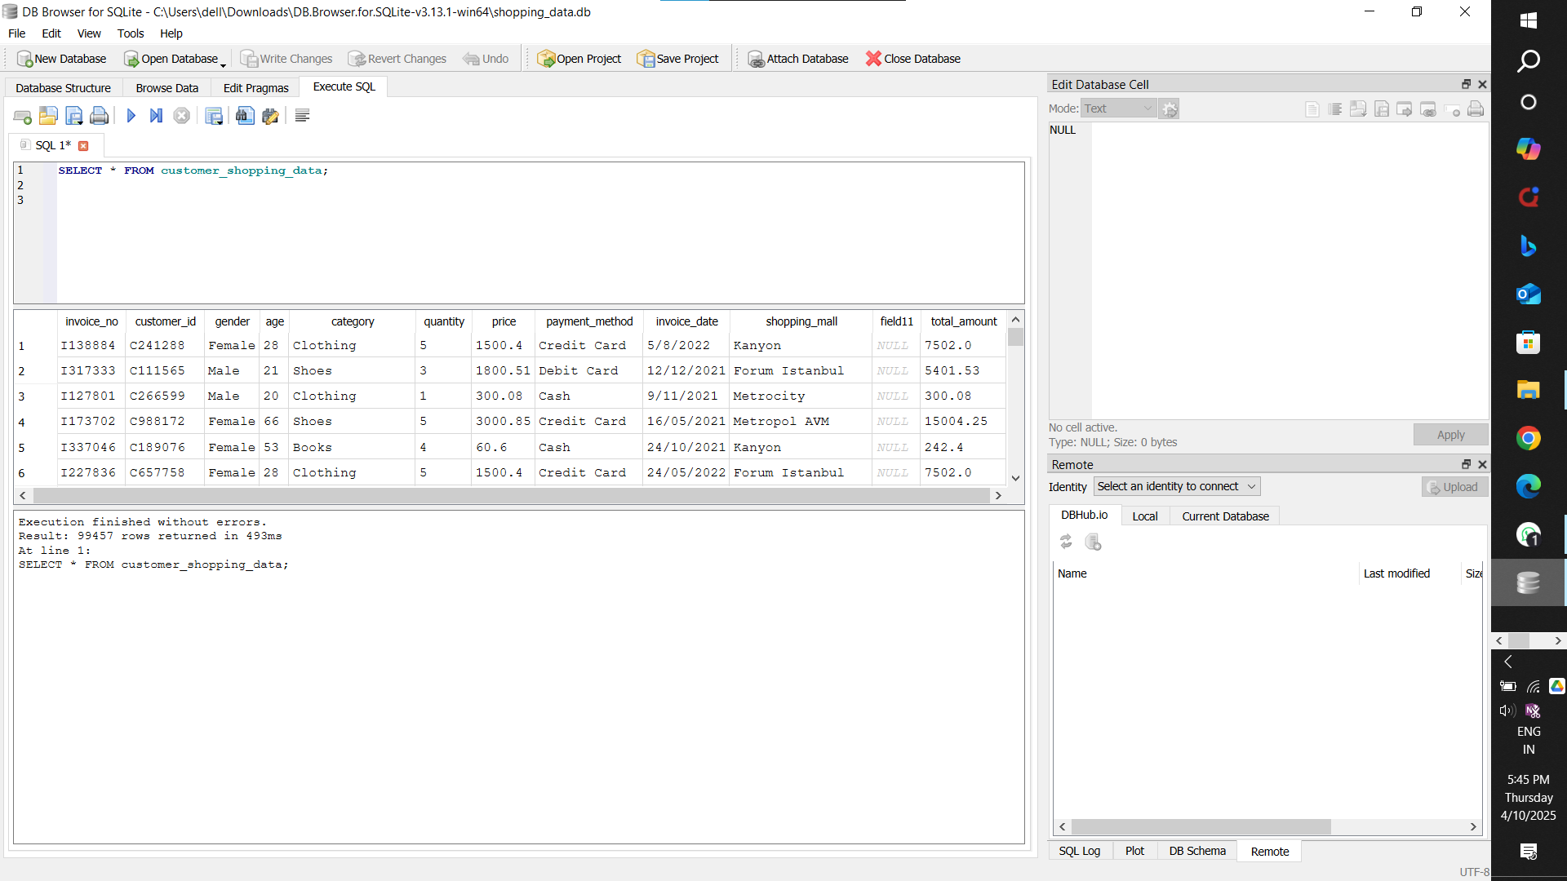

1. Limit to 10 rows SELECT * FROM customers_shopping_data LIMIT 10;

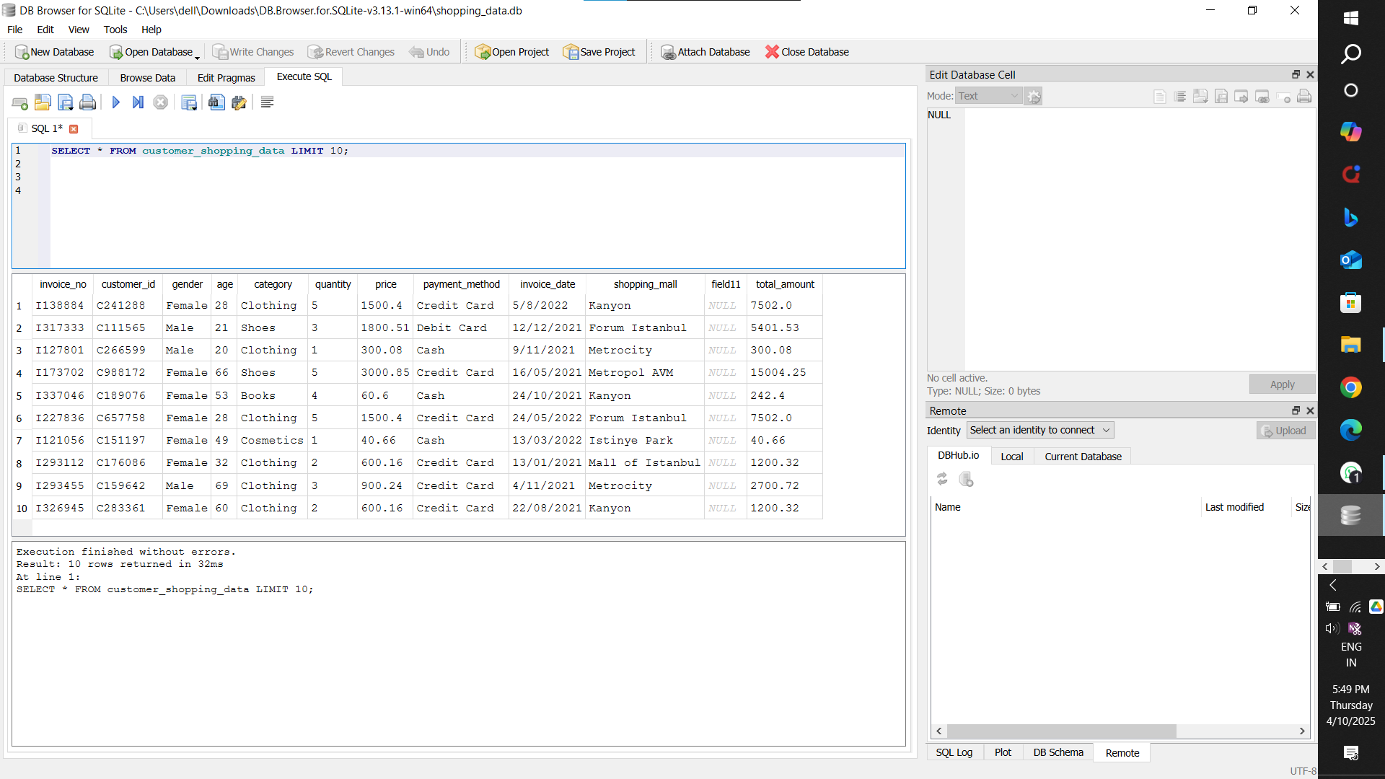

3)Use SELECT, WHERE, ORDER BY, GROUP BY

Total number of customers-

SELECT COUNT(DISTINCT customer_id) AS total_customers FROM customers_shopping_data;

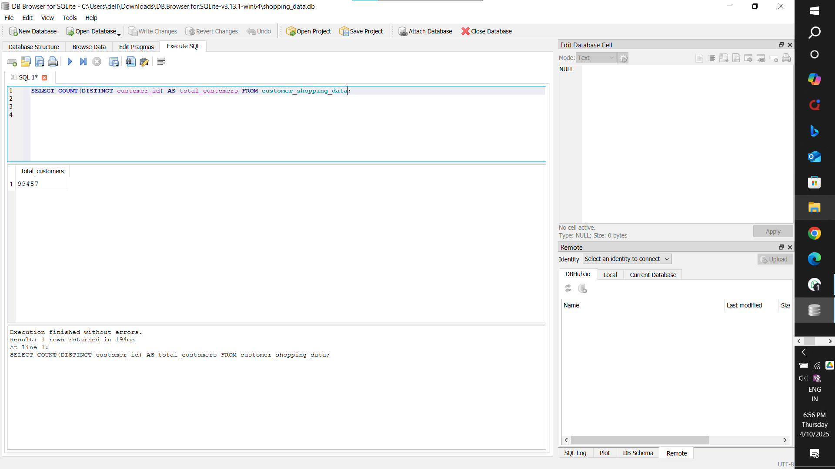

Total revenue SELECT SUM(price) AS total_amount FROM customer_shopping_data;

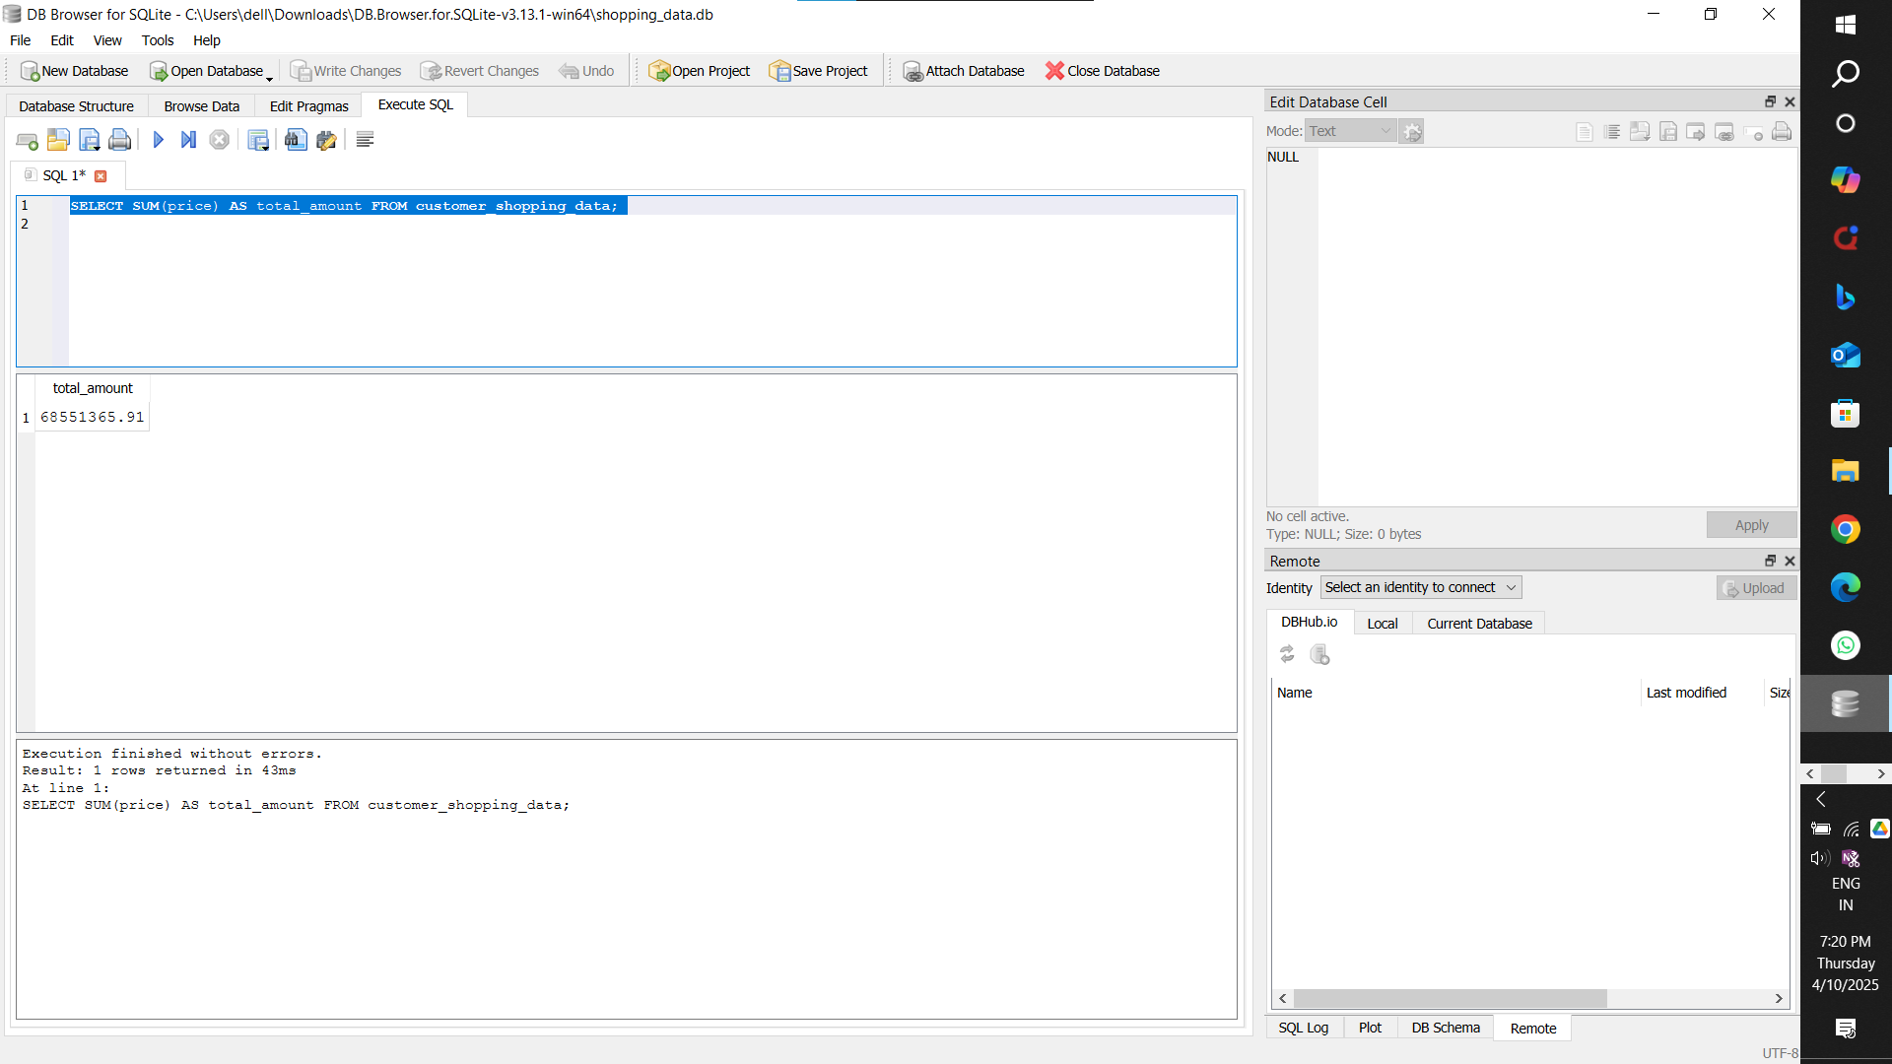

4) Use GROUP BY, ORDER BY

Total spent per customer less than 10000

SELECT customer_id, SUM(price) AS total_amount

FROM customer_shopping_data

GROUP BY customer_id

HAVING total_amount > 10000;

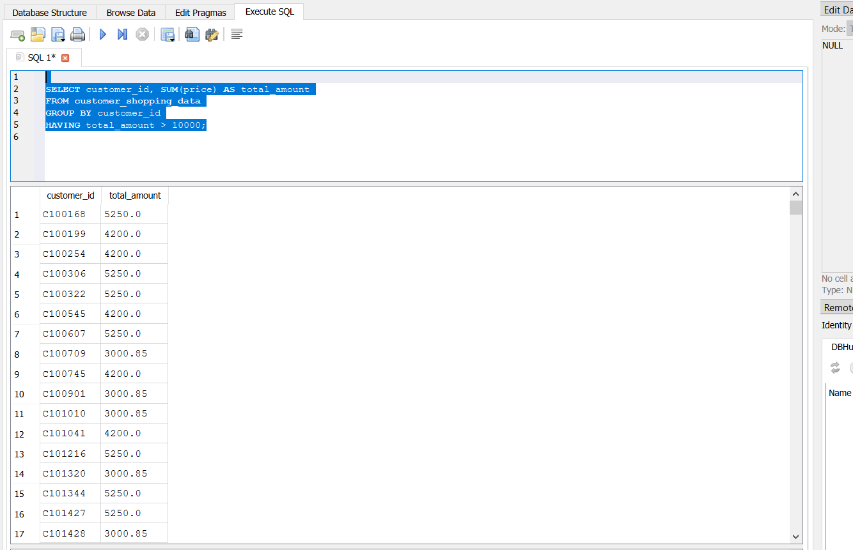

5) **sold categories** based on **total quantity** sold.

Top sold item

SELECT category, SUM(quantity) AS total_sold

FROM customer_shopping_data

GROUP BY category

ORDER BY total_sold DESC

LIMIT 1;

